

**School of Information Technology**

Course : Diploma in Business Informatics

Subject : ITP282 - Enterprise Application Development & Project

AY / Sem : 2018 S2

**Lab 3b: Website Navigation (.NET Navigation Controls)**

**OBJECTIVES:**

At the end of this practical, the student should be able to:

1. The relationships between the Web.sitemap file, the SiteMapDataSource control, Menu control and SiteMapPath control.
2. The structure of Web.sitemap files and be able to create them.
3. How to use and customise a Menu control.
4. How to use a SiteMapPath control.

## Exercise 1: Navigation Controls

ASP.NET provides several controls for ease of implementing site navigation. These controls are:

SiteMapDataSource: This control represents a web site's *Site Map*. A *Site Map* is an XML file that describes the logical structure of the web site and its pages.

SiteMapPath: This control displays the path to the current page, 'bread crumb' style.

Menu: This control displays the *Site Map* information as a menu.

### Adding a Site Map File

1. Add a new Site Map:
   1. Select *Website 🡺 Add New Item…*.
   2. Select *Site Map* and accept the default file name of *Web.sitemap*.
   3. Click the *Add* button.
2. Edit *Web.sitemap* and modify (do NOT just blindly add) the code as shown in Figure 1.

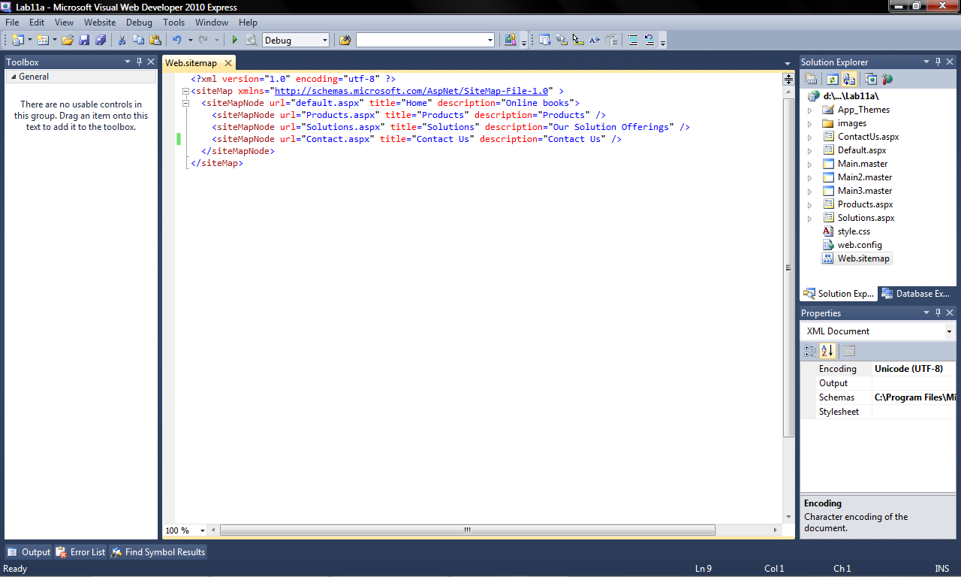

Figure 1

**Important:** The Web.sitemap file contains XML that describes the structure of the website. The Menu, SiteMapPath and other ASP.NET Navigation controls use the data in the Web.Sitemap file to automatically control the way they display themselves behave. This reduces a lot of the coding required to make such features work. They are also easier to modify when changes are required.

Examine the Web.sitemap and note the following:

* The <siteMap> element is the root element. There cannot be another <siteMap> element in the same file. There cannot be any other element at that level.
* Inside the <siteMap> element, there can only be one immediate child <siteMapNode> element.
* Inside the first <siteMapNode> element, there can be zero or more <siteMapNode> elements.

### Preparing the New Master Page

1. Add a new *Master Page* file named *Main3.Master*. Again, use Code Behind and do NOT Select a Master Page.
2. Copy the contents of *Main2.master* to *Main3.master* with the following steps:
   1. Delete all the code below the <%@ Master … %> directive of *Main3.master*.
   2. Copy all the code below the <%@ Master … %> directive of *Main2.master*.
   3. Paste the copied code below the <%@ Master … %> directive of *Main3.master*.
3. Close *Main2.master*.
4. Edit the *Page Directive* of all the *.aspx* files so that they use *Main3.master* as the Master Page.
5. Switch *Main3.master* to *Design View*.

### Adding a SiteMapDataSource

1. In the *ToolBox* Window, expand the *Data* section and drag and drop a *SiteMapDataSource* control in to the bottom area of the *Main3.Master* (see Figure 2). What is the ID of the *SiteMapDataSource* control? Take note of it.

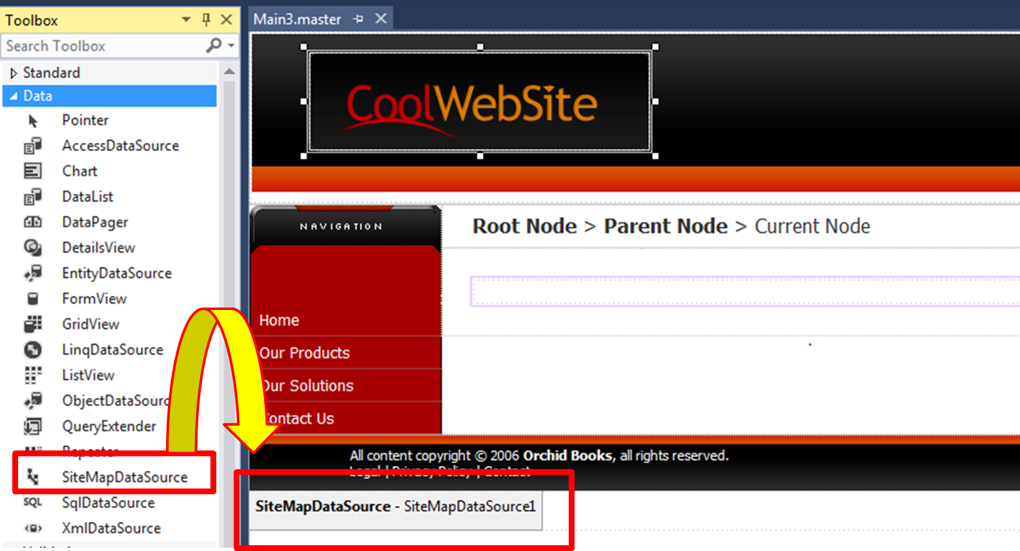

Figure 2

**Important:** The *SiteMapDataSource* control acts as an access control to the *Web.sitemap* file. The other *Navigation* controls like *Menu* and *Tree* uses the *SiteMapDataSource* to get the data in the file.

### Adding and Configuring a Menu Control

1. In *Main3.master*, look for the code highlighted in Figure 3 and delete them.

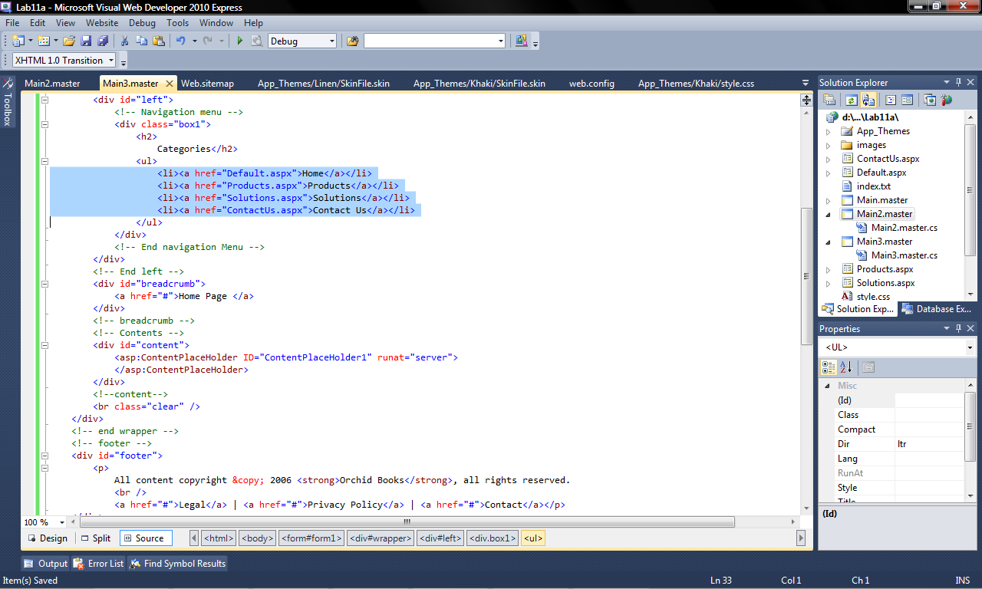

Figure 3

1. Add the code shown in Figure 4 where the deleted code used to be.

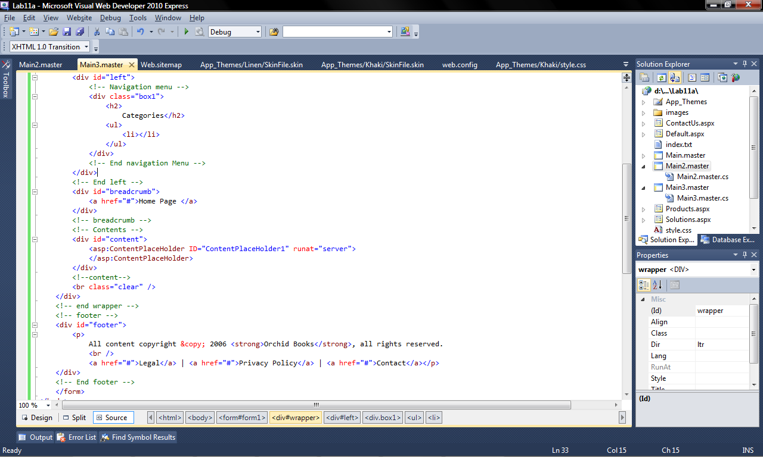

Figure 4

1. From the *Toolbox Window*, expand the *Navigation* section and drag a *Menu* control and drop it in between the <li></li> tags (see Figure 5). Your code should end up looking like Figure 6.

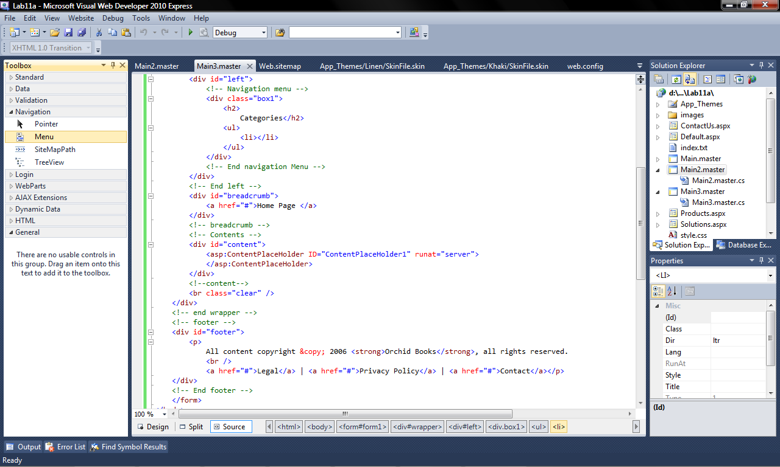

Figure 5

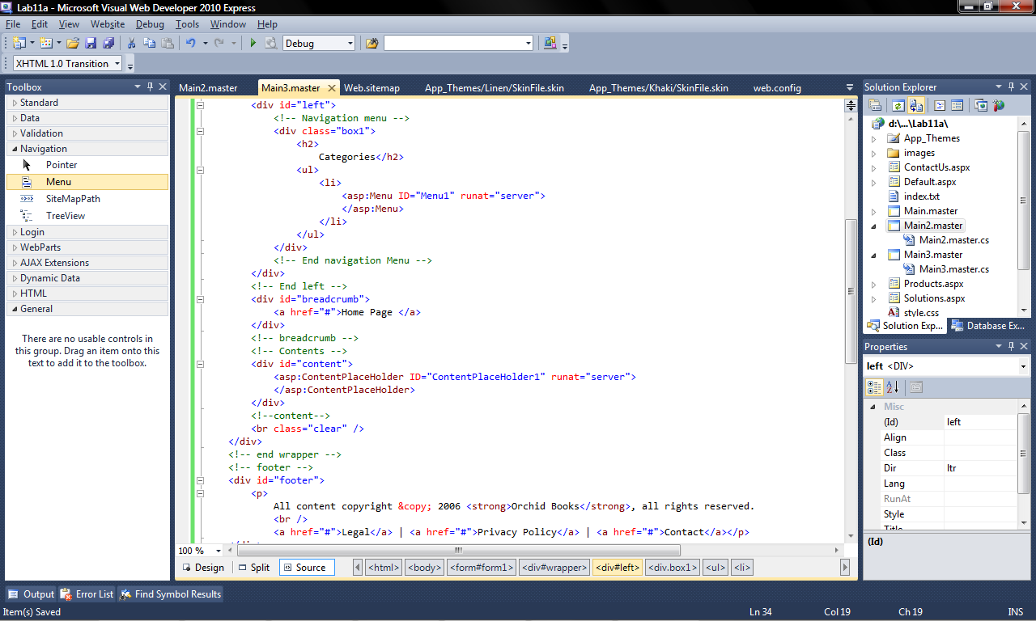

Figure 6

1. Switch *Main3.master* to *Design View*. Notice that the *Menu* has now changed and looks like Figure 7. Instead of *Home*, *Products*, etc, it now just has a whole bunch of *Root*. This is because the *Menu* control has no data to display.

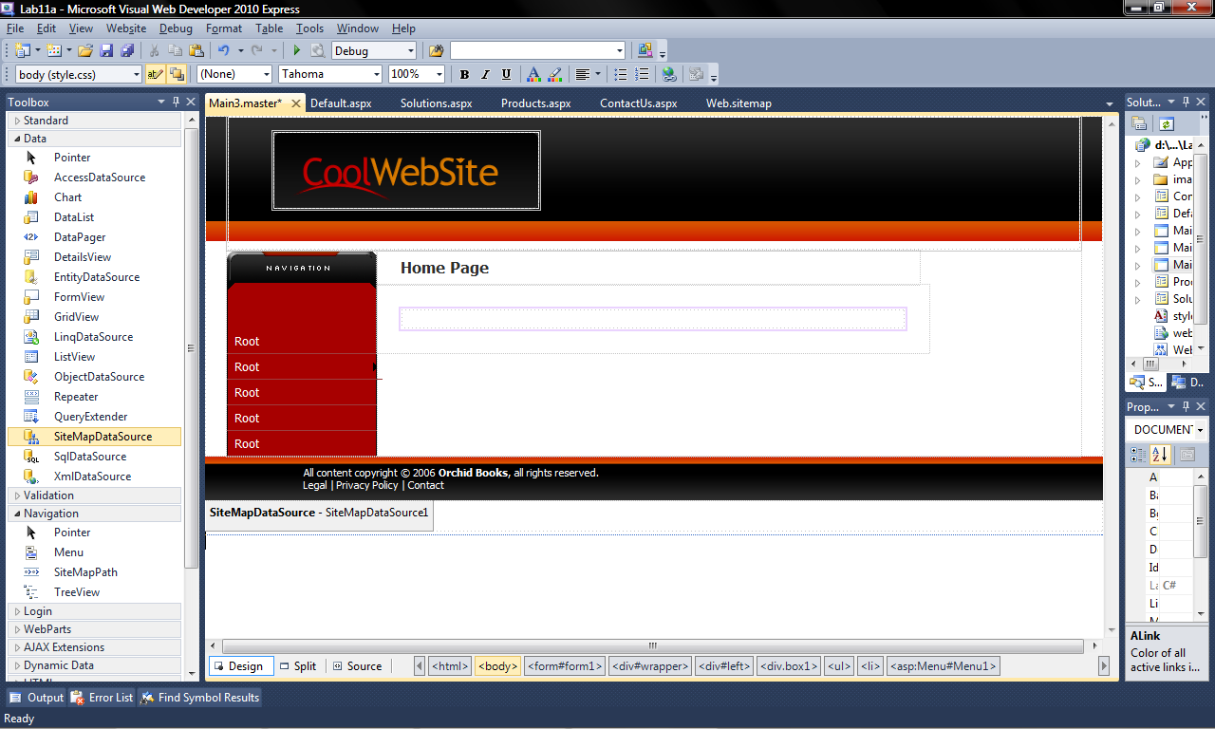

Figure 7

1. We will now link the *Menu* control to the *SiteMapDataSource* control so that it will display the data from the *Web.sitemap* file (see Figure 8).
   1. In *Design View*, click on the *Menu* control.
   2. Expand the *Menu Tasks* menu by clicking on the > button.
   3. In the *Choose Data Source* list, select *SiteMapDataSource1*. Note that this is the ID of the *SiteMapDataSource* control that we added in step 0.

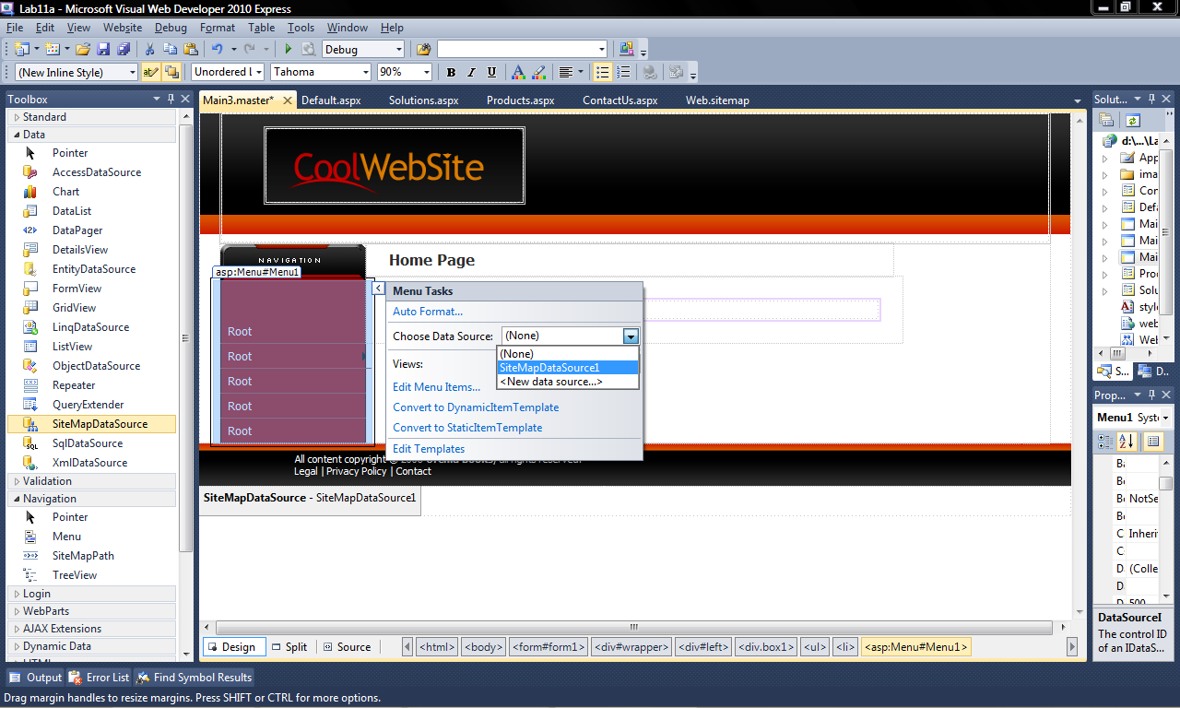

Figure 8

1. Use *View in Browser* to view *Default.aspx*. (If error is encountered: see [file](Lab%203b%20Step%2014%20error.docx))
   1. You should only see the *Home* item in the menu.
   2. Roll your mouse over the *Home* item, you will notice that a sub menu appears (may be hard to see) that shows the other 3 items.
2. We will now make some settings to change the way the menu is displayed.
   1. Go to *Design View* of *Main3.master*.
   2. Set the properties of the *Menu* control as shown in Table 1.
3. Now *View in Browser* the *Default.aspx* page again. You should see the full menu this time.
4. Try clicking on the different menu items to get to the different pages. You should have a problem getting to the *Contact Us* page. The reason is because we typed in the wrong URL for the page.
5. In VS, go to the *Web.sitemap* file. Check the *url* property of the *Contact Us* <siteMapNode> element and the filename of the *Contact Us* page. Change the *url* property to the correct URL.

Table 1

|  |  |
| --- | --- |
| **Property** | **Value** |
| **StaticDisplayLevels** | 2 |
| **StaticSubMenuIndent** | 0px (that is zero, not letter 'o') |

### Adding a SiteMapPath Control

1. In *Main3.master*, delete the code highlighted in Figure 9.

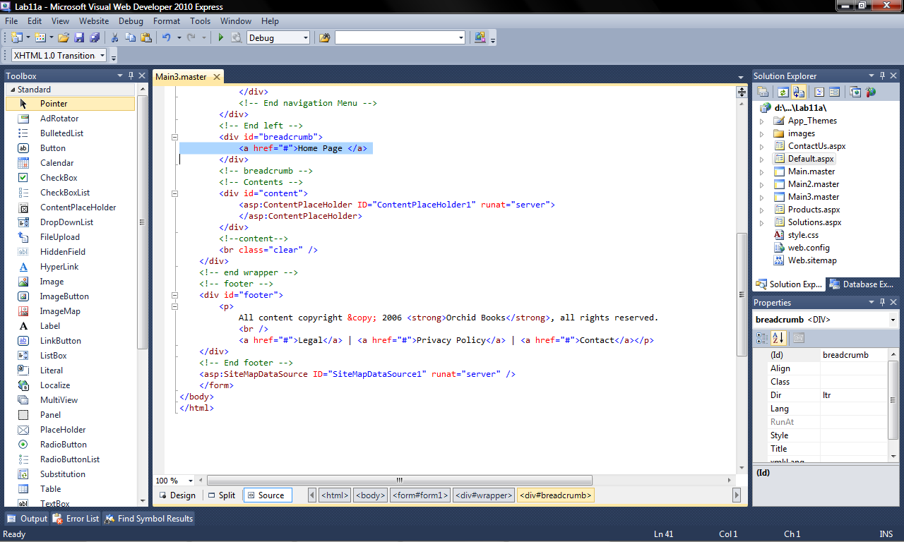

Figure 9

1. From the *ToolBox Window*, *Navigation* section, Drag and drop a *SiteMapPath* control into the space where we just deleted code. This control will automatically use the site information in the *Web.sitemap* file.
2. Test your work. As you navigate to the different pages using the *Menu* control, you should see the *SiteMapPath* control updating itself accordingly. Try clicking on the word *Home* in the *SiteMapPath* control. Where does it bring you?

### Exploring the Web.sitemap File

Examine the *Web.sitemap* file and try to figure out how the *url*, *title* and *description* properties of the <siteMapNode> elements are utilised by the Menu control. You would probably have figured out by now, that *url* property is the URL of the web page to link to.

1. Edit the *Web.sitemap* file so that the menu displays *Our Products* and *Our Solutions* instead of *Products* and *Solutions*.
2. Roll your mouse cursor over the *Our Solutions* item in the menu and pause. Notice the *Tool Tip* that appears (see Figure 10)? Where does that text appear in the *Web.sitemap* file?
3. Edit the *Web.sitemap* file so that "Browse Our Product Catalogue" is displayed when the user rolls the *Our Products* menu item.

Tool Tip

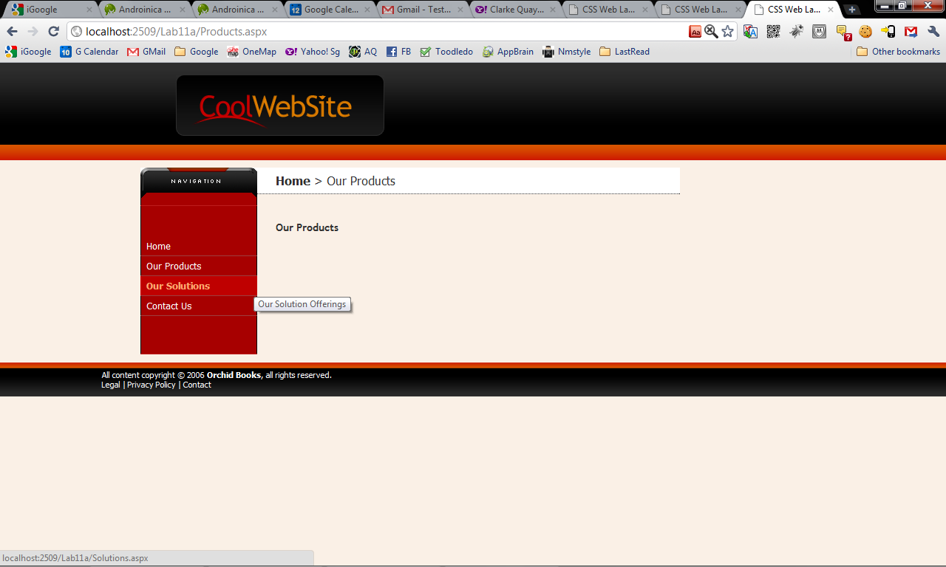

Figure 10

***========== End ==========***